1. **Homogeneity of variance**
2. Open the data you want to process in SPSS （For example, the data we use here are the data of “Number” and “Test Score” in the table “Experimental personnel's spatial cognitive ability data”）；
3. Execute on the menu bar: “Analyze→ Compare Means→ One-Way ANOVA”；

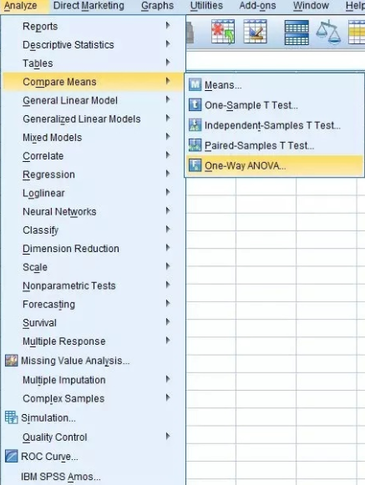

1. Opens the “One-Way ANOVA” dialog box；
2. In this dialog box, put the dependent variable in the “dependent list”, put the independent variable in the “Factor”, click “Post hoc”, select “Snk” and “Lsd”, and return to confirm “Ok”.
3. **Fisher's exact test**
4. Set variable: R*C table or four table settings;
5. Open the data you want to process in SPSS （In our experiments, we directly imported the data “Information statistics table of the recall elements and influencing factors of the verification experiment in Starlight Square”）；
6. 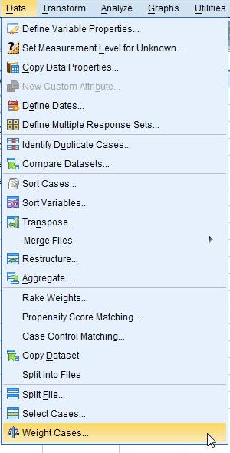Execute on the menu bar: “Data→ Weighted Cases”；
7. Opens the “Weighted Cases” dialog box;
8. Click on “Weighted cases by” to activate the “Frequency Variable” window, put the “freq” variable into the “Frequency Variable” column, and confirm “Ok”;
9. Execute on the menu bar: “Analyze→ Descriptive Statistics→ Crosstabs”； 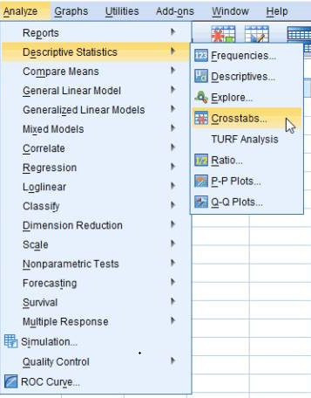
10. Opens the “Crosstabs” dialog box；
11. Put the variables " Recall " and " POI " into the "Row(s)" column and "Column(s) " column respectively;
12. Click on “Statistics”, and opens the “Crosstabs Statistics” dialog box；
13. Click on “Chi-square”;
14. Click “Continue→ Cells”;
15. Click the “Expected” option in the “Counts” column;
16. Click “Continue→ OK”;
17. Click “Analyze→ Descriptive Statistics→ Crosstabs” on the main page; 
18. Opens the “Crosstabs” dialog box；
19. Click on “Cells” and the “Crosstabs: Cells Display ” dialog box will pop up;
20. Click on the “Compare column proportions” and “Adjust p-values (Bonferroni method)” options in the “z-test” column;
21. Click “Continue→ OK”.